**BRAINROT RESEARCH**

**Het Shah (22001006)**

**Kirtan Visnagara (22000392)**

**WHAT IS BRAINROT?**

Brain rot is defined as progressive deterioration of one's own faculties of mind, intelligence, and concentration due to long exposure to an environment of information that is either excessive, low-grade, or repetitive, such as social media, mindless consumerism, and tech addiction. On these occasions, brain rot is often correlated with mental fatigue, lethargy, and lack of ability to process hard or meaningful information. It is not defined as a disorder but serves to explain the detrimental effects of modern digital consumption on the functioning of one's brain.

**How it happens?**

This happens when the brain is wired too long and exposed to heat and overage stimulation without or with little mental engagement. This phenomenon may lead to brain rot- scrolling through social media, binge-watching trashy TV dramas, or scrolling through engaging yet brain-numbing sensational news.  
  
Over time the chain will bring increased difficulty in something as simple as deep reading, intellectual discussion, of being mentally available to engage in some sustained effort.

Today, with instant gratification and minimal cognitive engagement considered digital habits, it is likely that brain rot has set in. Technology and entertainment are not bad in and of themselves, but with self-indulgence devoid of restraint, these vices tend to dull one's cognitive faculties, zone-out attention spans, and even trigger mental fatigue. To counteract brain rot, try engaging in activities that stimulate your brain, such as reading, critical thinking, doing art, or engaging in conversations. Try to replace some of your screen time with offline activities to keep the mind sharp and healthy.

Let's talk about to most critical and Brain threating subject to our coming generation.

**BRAINROT IN GenZ’s:**

**TIMES OF INDIA RESEARCH:**

https://timesofindia.indiatimes.com/education/news/brain-rot-oxfords-word-of-the-year-is-endemic-among-gen-z-students-how-its-robbing-them-of-their-potential/articleshow/115937916.cms

A Pew Research Center survey of teenage social media usage in 2023 is its emphasis on the way YouTube, TikTok, Snapchat, and Instagram control teens' lives. YouTube leads, with 90% of teenagers using it and 16% reporting they are "almost constant" in usage. TikTok is second, with 58% daily users and 17% describing their usage as relentless. Snapchat and Instagram also show high use, with Snapchat having 14% "almost constant" users compared to 8% for Instagram. Most teens are online and have a smartphone, and nearly half say they're online almost constantly, a new survey by the Pew Research Center of U.S. teens between the ages of 13 and 17 discovered Sept. 18-Oct, 2024.

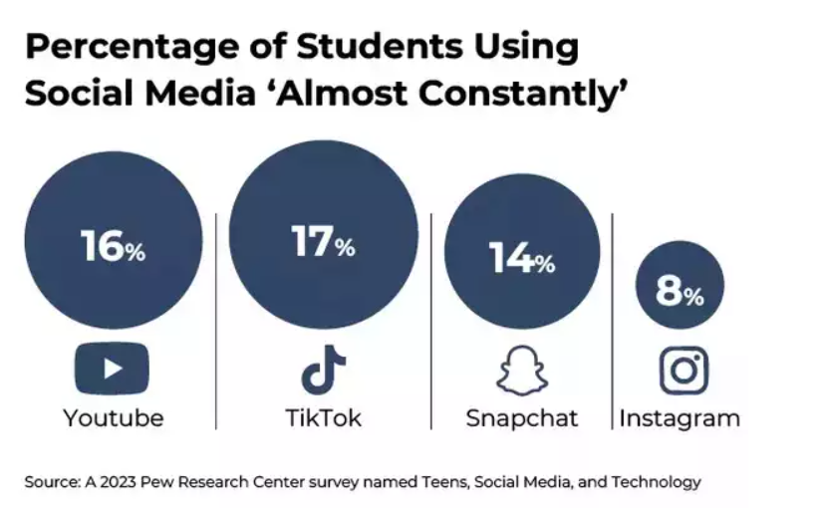

Figure Social Media Usage

The report is a cause for alarm regarding the use of social media affecting teens' capacity to keep it in check with other crucial aspects of life. Approximately 47% feel that it eats into time that could be devoted to cherished activities, frequently staying on longer than planned. Young adults aged between 18–22 are even more challenged, with 53% having problems with time management against 42% of adolescents.

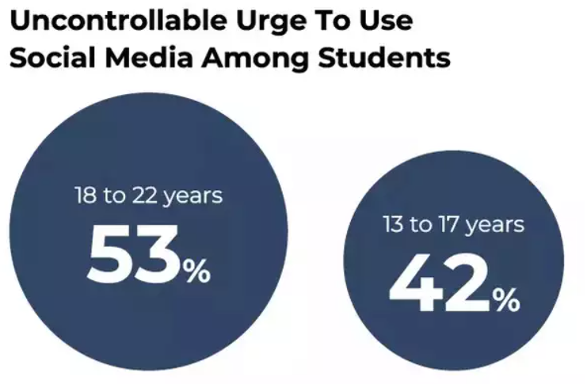

Figure Age Group Usag

**PEW RESEARCH:**

<https://www.pewresearch.org/internet/2024/12/12/teens-social-media-and-technology-2024/>

**YouTube** leads the list of the online sites we queried in our survey. **9/10** adolescents claim to use the site, down slightly from **95% in 2022**.  
**TikTok, Instagram, and Snapchat** are still used by most teens. About **6/10** teens report using TikTok and Instagram, and 55% report using Snapchat.

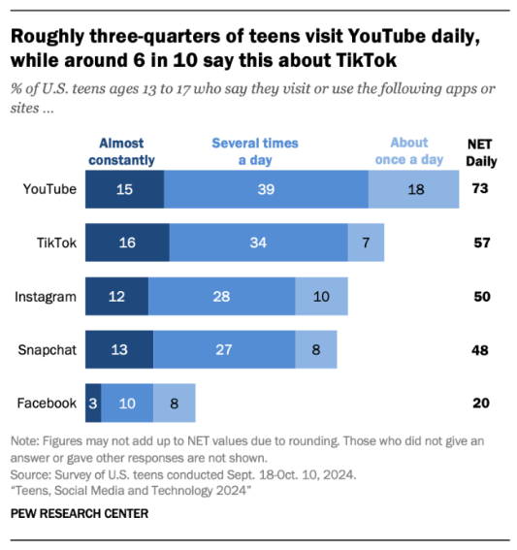

Figure GenZ's Consumption of social application

**What is affecting Genz’s because of this?**

* Death of critical thinking.
* Erosion of creativity
* Mental health fallout

**VERYWELL MIND RESEARCH:**

<https://www.verywellmind.com/brainrot-8677487>

### We all have our brains rottened. It's difficult not to when much of our day revolves around our phone. But there are some who are afflicted worse than others, and kids just happen to be the largest population since the pandemic. A 2023 systemic review discovered that children aged six to 14 years old's average screen use (starting from two hours and above) has significantly risen from 41.3% to 59.4% prior to and subsequent to January 2020, respectively.

### **Increases Risk of Anxiety and Depression**

### Dr. Kogan describes how excessive exposure to news on social media or other media can also enhance the dangers of depression and anxiety. Such excessive exposure can build an impression that the world is harmful, bad, and dangerous, thus leading to more anxiety and depression.

### **Potentially Lead to Addiction**

You may not consider social media to be addicting but in a way, it is. Social media has been programmed to activate the reward center of the brain. Once your brain gets continuously or highly stimulated, your brain creates patterns that resemble drug or other addiction.

**JOBIG RESEARCH:**

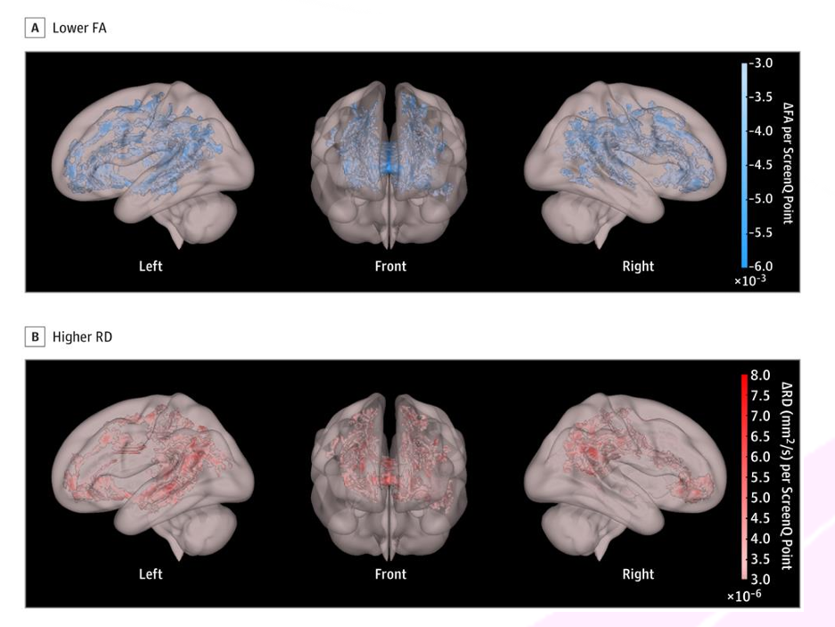

Figure Brain Affected by having brainrot

The research by Hutton et al. (2020) of 47 preschool children identified that greater screen time usage was associated with decreased microstructural integrity of brain white matter tracts involved in language, executive functions, and developing literacy skills.

**EXPERIMENT DETAILS AND RESULTS:**

**Dataset on Phone Addiction:**

<https://www.kaggle.com/datasets/sunitabakshi/phone-addiction>

To support the growing concern of "brain rot" in Gen Z and even millieinines, a relevant dataset on phone addiction was obtained from Kaggle. This dataset provides insight into screen time habits, usage patterns, and behavioral impacts associated with smartphone dependency. The following graph visualizes key aspects of the data, helping to establish a tangible connection between excessive phone usage and the cognitive effects described in this study.

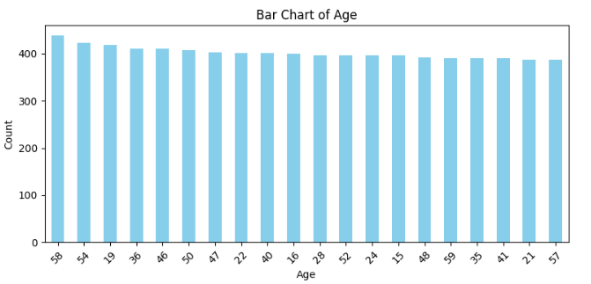

Figure Dataset result

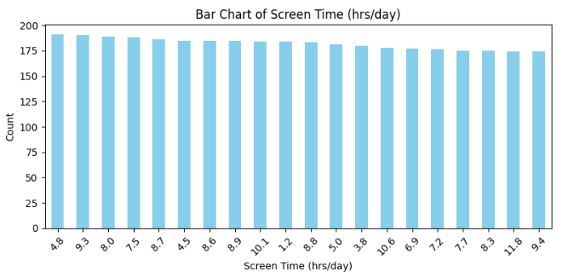

Figure Dataset result

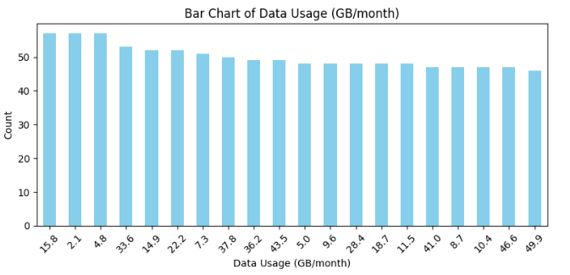

Figure Dataset result

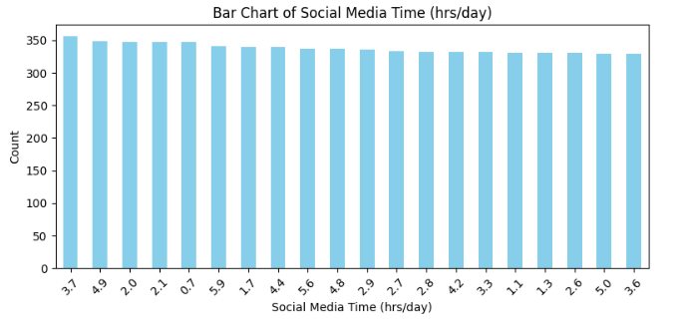

Figure Dataset result

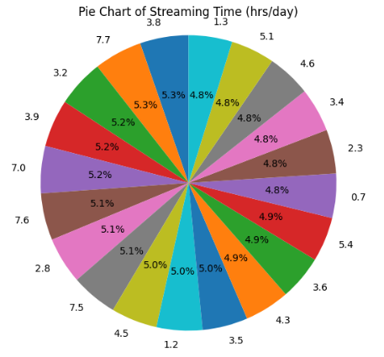

Figure Dataset result

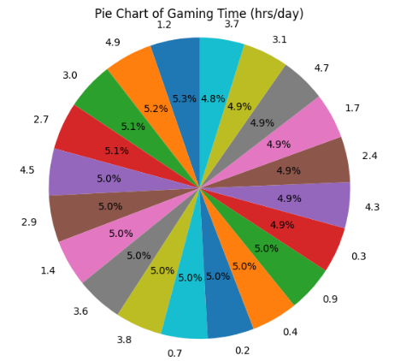

Figure Dataset result

**Conclusion:**

The dataset clearly highlights significant patterns of smartphone overuse, particularly among younger individuals. A large portion of users reported excessive screen time, frequent phone checking, and feelings of dependency—indicators that align with symptoms commonly associated with "brain rot," such as reduced attention span, mental fatigue, and lower cognitive engagement.

**Dataset of Brainrot & Digital Habit – Student Survey:**

**(Survey conducted by Het Shah & Kirtan Visnagara with guidance of Prof. Dhaval Mehta)**

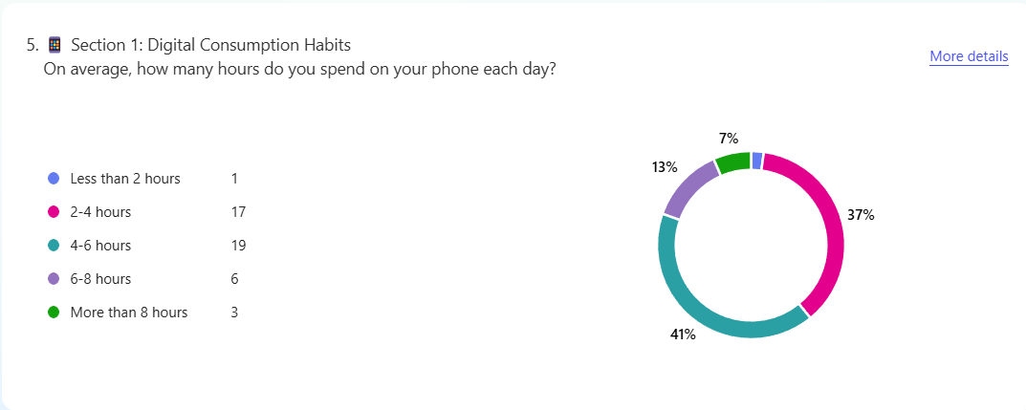

Figure Survey Result

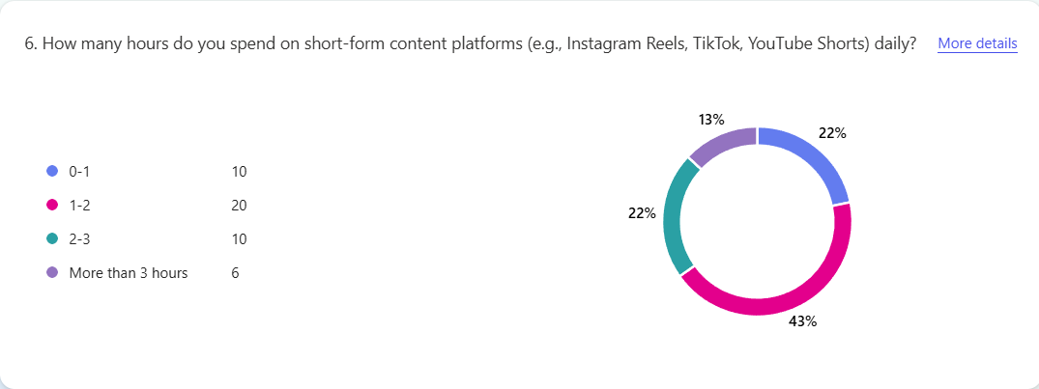

Figure Survey result

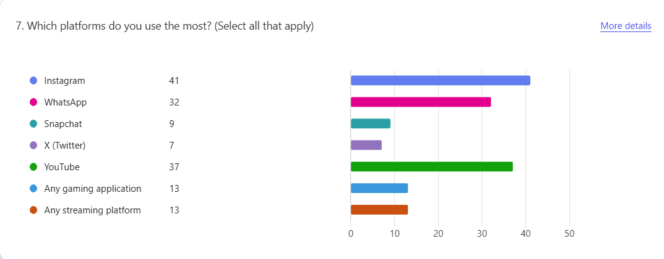

Figure Survey result

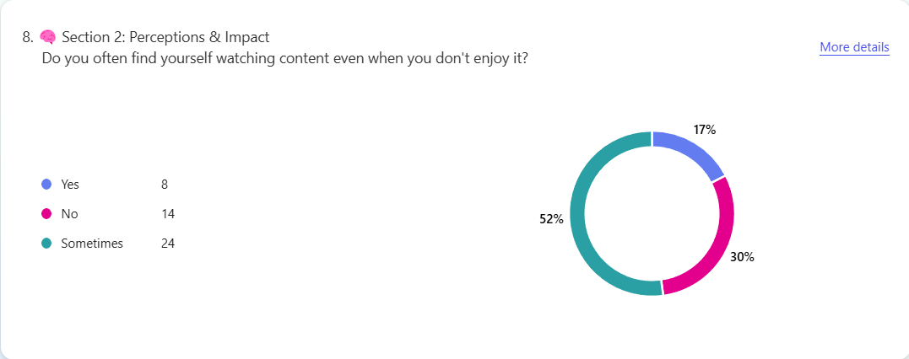

Figure Survey result

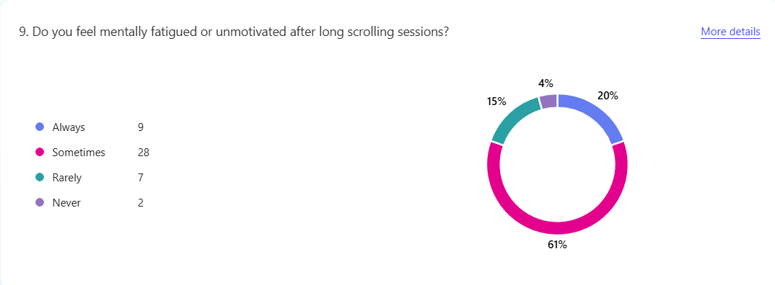

Figure Survey result

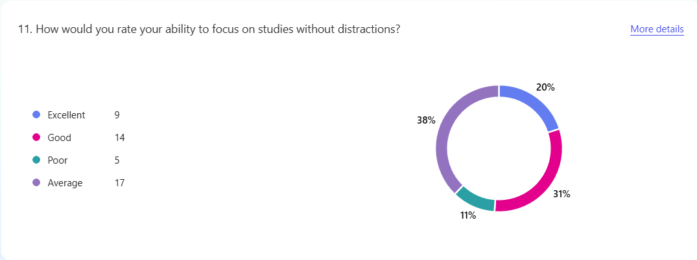

Figure Survey result

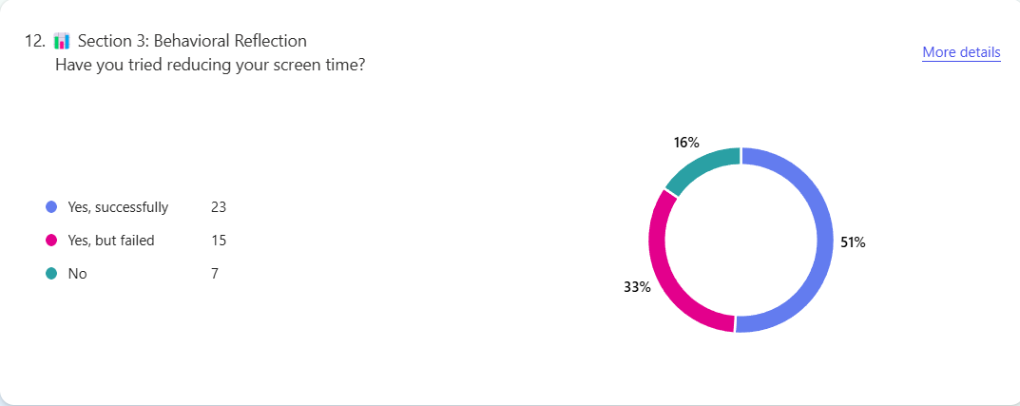

Figure Survey result

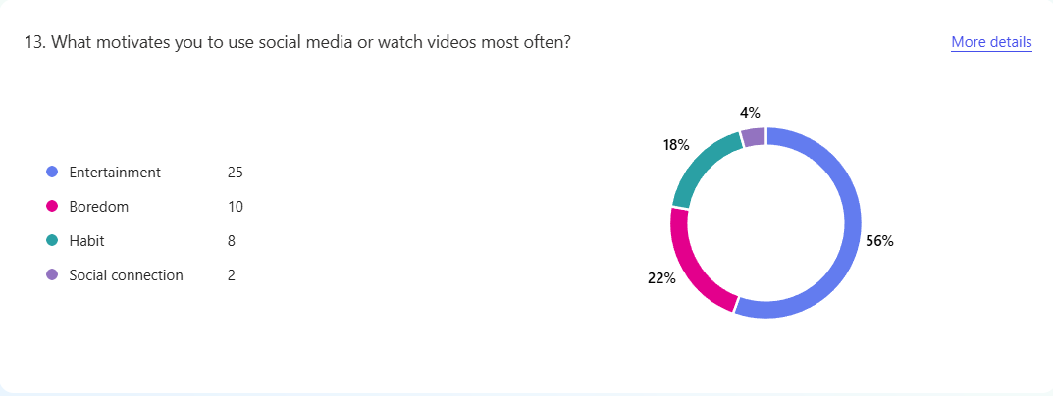

Figure Survey result

**Conclusion:**

The phenomenon of "brain rot" represents a growing concern in the digital age, particularly among Gen Z, who are most exposed to excessive screen time and content overload. This research has explored the cognitive and psychological impacts of continuous digital stimulation, drawing connections between frequent use of social media, short-form content platforms, and declining attention spans, reduced memory retention, and a general sense of mental fatigue.

The survey results and dataset analysis support the hypothesis that prolonged digital engagement—especially through entertainment and social networking apps—contributes to symptoms often described as "brain rot." Participants reported high daily screen time, compulsive app usage, and a notable decline in productivity and focus. These findings echo the rising concerns about digital well-being and suggest that unchecked consumption may have long-term consequences on mental and cognitive health.

In conclusion, while technology and media offer immense benefits, it is critical to foster digital mindfulness, encourage conscious consumption, and implement structured digital habits. Future research and institutional efforts should focus on awareness campaigns, self-regulation tools, and educational reforms to help Gen Z strike a healthier balance between their online and offline lives.